SHROPSHIRE CROWN GREEN BOWLING ASSOCIATION

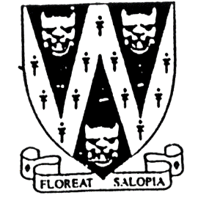
DAVE CARD ROSE BOWL &
BCGBA CENTENARY MIXED PAIRS

PLEASE NOTE: THIS IS A QUALIFIER FOR A NATIONAL COMPETITION,
SO WE CANNOT ACCEPT ENTRIES FROM THE HOST CLUB

Qualifying Rounds will be National Finals will be held at
at .
Greenfields BC To Be Confirmed.
Falstaff St. Shrewsbury.
On Sunday 25th May 2025 on Saturday 4th October 2025.
All games 21 up off 3. Commencing 10am
Start and Scratch time will be 10 am
No. of qualifiers dependent on entries BCGBA Dress Code Will Apply
Entries accepted on the day of competition

Entry fee £20.00 per pairing.
Dress Code for finals day. No entry fees will be accepted without fee.
No hard or block healed footwear. Cheques made payable to:
BLACK or Navy Blue trousers or “Shropshire Crown Green Bowling Association”
knee-length shorts to be worn. Entries with fees to: Mike Potter,
No Studs, Rivets, Zipped or 26, Trenleigh Gardens, Trench, TF2 6RN
External Pockets on legs. Email: potter.mike21@outlook.com
No jeans. No open-toed footwear Bank Transfer – Halifax Bank Acc. 10068464
Collared shirt to be worn. Bank Sort Code 11-07-75
If using bank transfer add your name as a note.
Also please email me your name & details.

Closing Date for Entries - Accepted on the day

SHROPSHIRE - BCGBA CENTENARY MIXED PAIRS ENTRY FORM (entries in block capitals)

Club……………………………………………………Email……………………………………………………………….

BCGBA No. NAME. CLUB. ALSO A MEMBER OF: Mobile number/email
1
2
3
4
5

Number of entries ………………..@ £20.00 Total £………… enclosed

