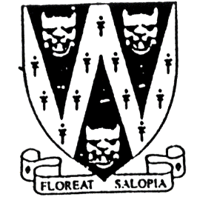
SHROPSHIRE CROWN
GREEN BOWLING
ASSOCIATION

Winner will receive the John BowersE.A. Clare Cup will be
SENIOR MERIT

Entries are invited for the 2025 Shropshire Individual Merit Competition

32 Qualifiers for Finals Day

Competitors can opt for qualifying sessions that will be played on

Wed. 14th May (7pm) Sat. 17th May (6pm) Sun. 18th May (1pm)

Note: allocation of greens will be dependent on number of entries
CLOSING DATE FOR ENTRIES: Wed. 7th May 2025
Finals Day will be on Sunday 22nd June 2025 from 11am
Venue will be announced after the qualifiers are known.

B.C.G.B.A. dress code will be strictly enforced on finals day. For green allocations
No hard or block heeled footwear allowed on the green. go to our website at
BLACK or NAVY BLUE trousers or knee-length shorts. www.scgba.co.uk
No studs, rivets, zipped pockets or external pockets on legs. after the entry
No Jeans. No Open-toed footwear. Collared Shirt to be worn closing date

Prize Money (Subject to entries) Entries “Gentlemen bowlers only”
Entry Fee: £15.00 per player. Only paid entries will be in the draw.
Cheques payable to Shropshire Crown Green Bowling Association.
Send to: Rob Burroughs, 7 Bostock Close, Admaston, Telford, TF5 0AG.
Phone: 07901 229623
Email: scgba21@gmail.com
Payment details available on entry

SHROPSHIRE COUNTY INDIVIDUAL MERIT ENTRY FORM (entries in block capitals)

Club……………………………………………………Email……………………………………………………………….
BCGBA No. NAME. CLUB. Mobile number/email Preferred Qualifying Date(s)
1
2
3
4

Number of entries ………………..@ £15.00 Total £………… enclosed

