SHROPSHIRE CROWN GREEN BOWLING ASSOCIATION

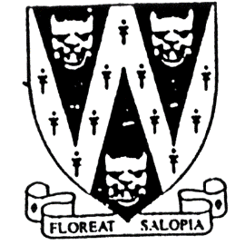
GIRLS MERIT

One day competition Open to Girl bowlers
All entrants must NOT have reached the age of 18 on 1st January 2025
Entries will be accepted on the day
In order to give an idea of entry numbers, please reserve your place by 26th July

To be played on This is a qualifying event for the
Saturday 2nd August 2025 BCGBA Girls Merit (06.9.25) ?
Commencing 10 am to be played at
Venue: Meole Brace BC TO BE ADVISED.
Meole Rise,
Shrewsbury. SY3 9JF
B.C.G.B.A. dress code will be enforced at Girls Merit Finals Day.
No hard or block heeled footwear allowed on the green.
Black or Navy Blue trousers or knee-length shorts to be worn.
No studs, rivets, zipped pockets or external pockets on legs.
No Jeans. No open-toed footwear. Collared shirt to be worn.
No Dress Code will be enforced at our qualifying competition.

Entry fee £10 per player. No entries will be accepted without fee.
Please make cheque payable to “Shropshire Crown Green Bowling Association”
Entries with fees to: Mike Potter, 26 Trenleigh Gardens, Trench TF2 6RN
Email: potter.mike21@outlook.com
Bank Transfer Details: Halifax Bank Account No. 10068464
Bank Sort Code: 11-07-75
Please email me with your name & details. If using bank transfer add your name as a note.

BCGBA GIRLS MERIT ENTRY FORM (entries in block capitals)

Club……………………………………………………Email……………………………………………………………….

BCGBA No. NAME. CLUB. ALSO A MEMBER OF: Date of Birth
1
2
3
4

Number of entries ………………..@ £10 Total £………… enclosed

