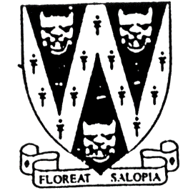
SHROPSHIRE CROWN GREEN BOWLING ASSOCIATION

DAVE CARD MEMORIAL
MIXED PAIRS ROSE BOWL

To be held on Sunday 30th April 2023
Venue: Bridgnorth Bowling Club.
Off Cricket Meadow,
Bridgnorth. WV16 4LB
Commencing 10am
Entries will be accepted on the day Prize money dependant on Entries.

A maximum of ONE HOME BOWLER per pairing are permitted to enter
with a partner but will be handicapped 2 chalks

B.C.G.B.A. dress code will be enforced throughout competition
No hard or block heeled footwear allowed on the green.
BLACK or NAVY BLUE trousers or knee-length shorts to be worn.
No studs, rivets, zipped pockets or external pockets on legs.
No Jeans. No open-toed footwear. Collared shirt to be worn.

Entry fee £12.00 per pair. No entries will be accepted without fee.

Please make cheque payable to “Shropshire Crown Green Bowling Association”

Entries with fee to: Mike Potter, 26 Trenleigh Gardens, Trench TF2 6RN
Email: potter.mike21@outlook.com

DAVE CARD MIXED PAIRS ENTRY FORM

Club……………………………………………………Email……………………………………………………………….

BCGBA No. NAME. CLUB. ALSO A MEMBER OF: Mobile number/email
1
2
3

Number of entries ………………..@ £12.00 Total £………… enclosed

