SHROPSHIRE CROWN GREEN BOWLING ASSOCIATION

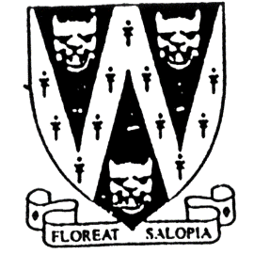
Father & Son Doubles
ONE DAY COMPETITION. All games 21 up

Pairings from different clubs are permitted.

To be played on Saturday 17th June 2023
Commencing 10 a.m.
Venue: To Be Advised
In North Shropshire Area

B.C.G.B.A dress code will be enforced throughout competition
No hard or block heeled footwear allowed on the green.
BLACK or NAVY BLUE trousers or knee-length shorts to be worn.
No Studs, rivets, zipped or external pockets on legs.
No jeans. No Open-toed footwear. Collared shirt to be worn

ENTRY FEE: £12.00 per pair. No entries will be accepted without fee.
Entries will be accepted on the day of the competition
Please make cheques payable to: Shropshire Crown Green Bowling Association.

Entries with fees to: Mike Potter, 26 Trenleigh Gardens, Trench TF2 6RN
Email: potter.mike21@outlook.com

Home Bowlers are permitted to enter but will
give opponents a handicap of 2 chalks per player

PRIZE MONEY SUBJECT TO NUMBER OF ENTRIES

FATHER AND SON ENTRY FORM (entries in block capitals)

Club……………………………………………………Email……………………………………………………………….
BCGBA No. NAME. CLUB. ALSO A MEMBER OF: Mobile number/email
1
2
3
4

Number of entries ………………..@ £12.00 Total £………… enclosed

