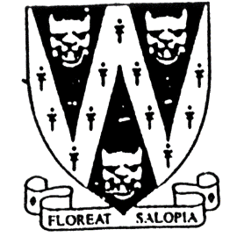
SHROPSHIRE CROWN GREEN BOWLING ASSOCIATION

SENIOR COUNTY MERIT

Entries are invited for the 2023 Shropshire Individual Merit Competittion

32 Qualifiers

Qualifying rounds will be played on

Players can opt for Saturday 20th May (6pm) (N.Shrop. area)

any of the available and

area and date Sunday 21st May (1pm) (S’bury & Telford area)

Note: allocation of greens will be dependent on number of entries
CLOSING DATE FOR ENTRIES: Sunday 6th May 2023

Finals Day will be on Sunday 25th June 2023 from 11am
Venue will be announced after the qualifiers are known.

Note: Entry Fee includes the new FOOTER LEVY (£1) imposed on
competitions & payable to the B.C.G.B.A.

B.C.G.B.A. dress code will be strictly enforced on finals day. For green allocations
No hard or block heeled footwear allowed on the green. go to our website at
BLACK or NAVY BLUE trousers or knee-length shorts. www.scgba.co.uk
No studs, rivets, zipped pockets or external pockets on legs. after the entry
No Jeans. No Open-toed footwear. Collared Shirt to be worn closing date

Prize Money (Subject to entries) Entries “Gentlemen bowlers only”
Entry Fee: £11.00 per player. Only paid entries will be in the draw.
Cheques payable to Shropshire Crown Green Bowling Association.
Send to: Mike Potter, 26 Trenleigh Gardens, Trench TF2 6RN
Email: potter.mike21@outlook.com

SHROPSHIRE COUNTY INDIVIDUAL MERIT ENTRY FORM (entries in block capitals)

Club……………………………………………………Email……………………………………………………………….

BCGBA No. NAME. CLUB. Mobile number/email Preferred Qualifying Date & Area
1
2
3
4

Number of entries ………………..@ £11.00 Total £………… enclosed

