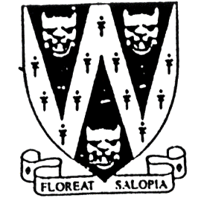
SHROPSHIRE CROWN GREEN BOWLING ASSOCIATION

DAVE CARD MEMORIAL
MIXED DOUBLES ROSE BOWL

To be held on Sunday 22nd May 2022
Venue: Trench BC,
Trench Road, Trench, Telford. TF2 6NU
Commencing 10am Games to be 21 up off 3
Entries will be accepted on the day Prize money dependant on Entries.
A maximum of ONE HOME BOWLER per pairing is permitted to enter with a
partner but will be handicapped 2 chalks

Played in conjunction with the BCGBA Centenary Mixed Pairs
To qualify for the National Finals day
Date: 1st October 2022
Venue: Heaton Park, Greater Manchester
Number of Qualifiers dependant on entries.

B.C.G.B.A. dress code will be enforced throughout competition
No hard or block heeled footwear allowed on the green.
Only BLACK trousers or BLACK knee-length shorts to be worn.
No studs, rivets, zipped pockets or external pockets on legs.
No Jeans. No open-toed footwear. Collared shirt to be worn.

Entry fee £12.00 per pair. No entries will be accepted without fee.
Please make cheque payable to “Shropshire Crown Green Bowling Association”
Entries with fee to: Mike Potter, 26 Trenleigh Gardens, Trench TF2 6RN
Email: potter.mike21@outlook.com

DAVE CARD MIXED DOUBLES ENTRY FORM

Club……………………………………………………Email……………………………………………………………….

BCGBA No. NAME. CLUB. ALSO A MEMBER OF: Mobile number/email
1
2
3

Number of entries ………………..@ £12.00 Total £………… enclosed

