SHROPSHIRE CROWN GREEN BOWLING ASSOCIATION

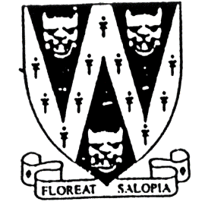
JUNIOR COUNTY MERIT

and Peter Ashton Consolation Cup.
One day competition Open to Male and Female bowlers
All entrants must NOT have reached the age of 18 on 1st January 2022
Entries will be accepted on the day
In order to give an idea of entry numbers, please reserve your place by Sat. 3rd July

To be played on This is a qualifying event for the
Saturday 2nd July 2022 BCGBA Junior Merit (20.8.22)
Commencing 10 am to be played at Heaton Park,
Venue: Sir John Bayley Club Middleton Rd, Higher Blackley
23, Haygate Road, Greater Manchester. M25 2SW
Wellington. Telford. TF1 1QX

B.C.G.B.A. dress code will be enforced throughout competition.
No hard or block heeled footwear allowed on the green.
Only BLACK trousers or BLACK knee-length shorts to be worn.
No studs, rivets, zipped pockets or external pockets on legs.
No Jeans. No open-toed footwear. Collared shirt to be worn.

Prize money is subject to entries.

Entry fee £5.00 per player. No entries will be accepted without fee.
Please make cheque payable to “Shropshire Crown Green Bowling Association”
Entries with fees to: Mike Potter, 26 Trenleigh Gardens, Trench TF2 6RN
Email: potter.mike21@outlook.com

SHROPSHIRE COUNTY JUNIOR MERIT ENTRY FORM (entries in block capitals)

Club……………………………………………………Email……………………………………………………………….

BCGBA No. NAME. CLUB. ALSO A MEMBER OF: Mobile number/email
1
2
3
4

Number of entries ………………..@ £5.00 Total £………… enclosed

