SHROPSHIRE CROWN GREEN BOWLING ASSOCIATION

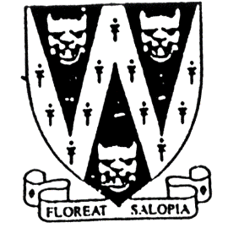
Father & Son Doubles
ONE DAY COMPETITION. All games 21 up

Pairs from two different clubs are permitted.

To be played on Saturday 18th June 2022
Commencing 10 a.m.
Venue: MEOLE BRACE B.C.
Meole Rise, Shrewsbury SY3 9JF

B.C.G.B.A dress code will be enforced throughout competition
No hard or block heeled footwear allowed on the green.
BLACK trousers or BLACK knee-length shorts.
No Studs, rivets, zipped or external pockets on legs.
No jeans. No Open-toed footwear. Collared shirt to be worn

ENTRY FEE: £12.00 per pair. No entries will be accepted without fee.
Entries will be accepted on the day of the competition
Please make cheques payable to: Shropshire Crown Green Bowling Association.

Entries with fees to: Mike Potter, 26 Trenleigh Gardens, Trench TF2 6RN
Email: potter.mike21@outlook.com

Home Bowlers are permitted to enter but will
give opponents a handicap of 2 chalks per player

PRIZE MONEY SUBJECT TO NUMBER OF ENTRIES

FATHER AND SON ENTRY FORM (entries in block capitals)

Club……………………………………………………Email……………………………………………………………….
BCGBA No. NAME. CLUB. ALSO A MEMBER OF: Mobile number/email
1
2
3
4

Number of entries ………………..@ £12.00 Total £………… enclosed

