SHROPSHIRE CROWN
GREEN BOWLING
ASSOCIATION

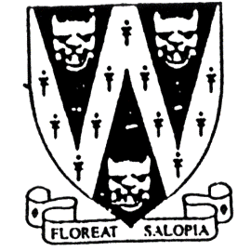
COUNTY HANDICAP

Winner will receive the John Bowers Cup
The E.A. Clare Cup will be awarded to the best novice

Open to all bowlers of SCGBA affiliated clubs

To be held on Bank Holiday Monday 2nd May 2022
Start and Scratch time 10.00 am
Venue: Old Shrewsbury BC, Shrewsbury SY1 1XR

B.C.G.B.A dress code will be enforced for quarter finals onward
No hard or block heeled footwear allowed on the green.
BLACK trousers or BLACK knee-length shorts.
No Studs, rivets, zipped or external pockets on legs.
No jeans. No Open-toed footwear. Collared shirt to be worn

Entries will be accepted on the day.

Entry Fee £10.00 per player. No entries will be accepted without fee.
Cheques payable to: “Shropshire Crown Green Bowling Association”
Entries with fees to be sent to: Mike Potter, 26 Trenleigh Gardens, Trench TF2 6RN
Email: potter.mike21@outlook.com

Home Bowlers are now permitted to enter but will
incur an added handicap of 2 chalks per player

Prize Money is subject to entries

---------PLEASE DETACH & RETURN ------------------

SHROPSHIRE COUNTY HANDICAP ENTRY FORM (entries in block capitals please)

Club……………………………………………………Email……………………………………………………………….

BCGBA No. NAME. CLUB. also a member of: Mobile number/email
1
2
3
4
5

Number of entries ………………..@ £10.00 Total £………… enclosed

