SHROPSHIRE CROWN GREEN BOWLING ASSOCIATION

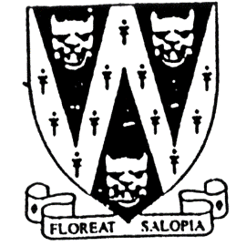
18 - 25 MERIT

Open to Male and Female bowlers
Entrants must have reached the age of 18 and under 26 on 1st January 2022
Entries will be accepted on the day

To be played on The 4 semi-finalists will qualify for
Saturday 9th July 2022. The BCGBA 18 - 25 Merit (14.8.22)
Commencing 10 am to be played at Heaton Park,
Venue: Wem Sports BC, Middleton Rd, Higher Blackley
Bowens Field, Greater Manchester. M25 2SW
Wem. SY4 5AP
B.C.G.B.A. dress code will be enforced for Quarter Finals onward.
No hard or block heeled footwear allowed on the green.
Only BLACK trousers or BLACK knee-length shorts to be worn.
No studs, rivets, zipped pockets or external pockets on legs.
No Jeans. No open-toed footwear. Collared shirt to be worn.

Prize money is subject to entries.

Entry fee £10.00 per player. No entries will be accepted without fee.
Please make cheque payable to “Shropshire Crown Green Bowling Association”
Entries with fees to: Mike Potter, 26 Trenleigh Gardens, Trench TF2 6RN
Email: potter.mike21@outlook.com

SHROPSHIRE COUNTY JUNIOR MERIT ENTRY FORM (entries in block capitals)

Club……………………………………………………Email……………………………………………………………….

BCGBA No. NAME. CLUB. ALSO A MEMBER OF: Mobile number/email
1
2
3
4

Number of entries ………………..@ £10.00 Total £………… enclosed

