SHROPSHIRE CROWN GREEN BOWLING ASSOCIATION

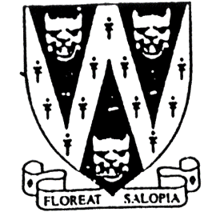
COUNTY DOUBLES

Winners receiving the John Bowers Challenge Cup

Gentleman Bowlers only

To be held on
Sunday 28th August 2022
Commencing at 10.00 am
One Day Competition
Venue: To Be Confirmed Nearer Comp. Date
Entries will be permitted on the day
Prize money dependant on entries
Home Bowlers are now permitted to enter but will
incur a handicap of 2 chalks per player

B.C.G.B.A. dress code will be enforced throughout the competition.
No hard or block heeled or open-toed footwear allowed on the green.
Only BLACK trousers or BLACK knee-length shorts.
No studs, rivets, zipped pockets or external pockets on legs.
No Jeans. Collared shirt to be worn.

Entry fee £12.00 per pair. No entries will be accepted without fee.
Please make cheque payable to “Shropshire Crown Green Bowling Association”
Entries with fee to: Mike Potter, 26 Trenleigh Gardens, Trench TF2 6RN
Email: potter.mike21@outlook.com

COUNTY DOUBLES ENTRY FORM (entries in block capitals)

Club……………………………………………………Email……………………………………………………………….

BCGBA No. NAME. CLUB. ALSO A MEMBER OF: Mobile number/email
1
2
3

Number of entries ………………..@ £12.00 Total £………… enclosed

